ASSIGNMENT : 7
Rollback and Commit commands Create Teacher table with the following fields (Name, DeptNo, Date of joining, DeptName, Location, Salary)
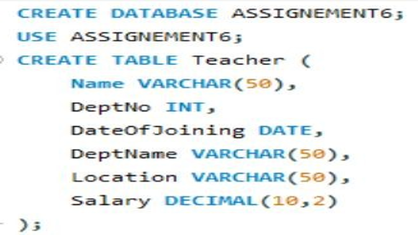
( a ) Insert five records

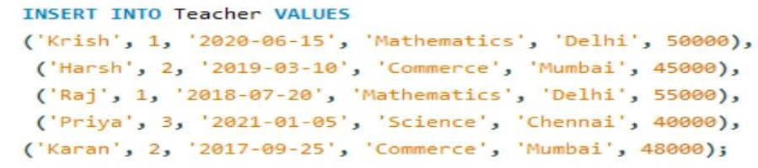

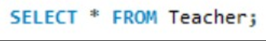

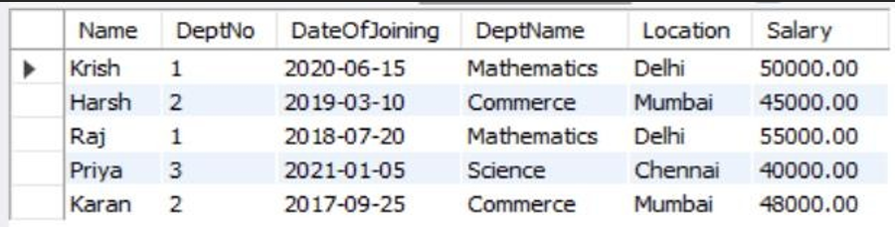

( b ) Give Increment of 25% salary for Mathematics Department .
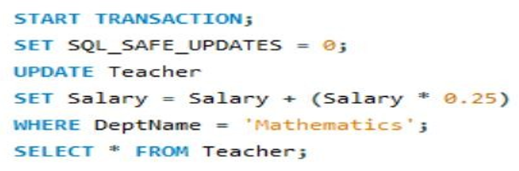
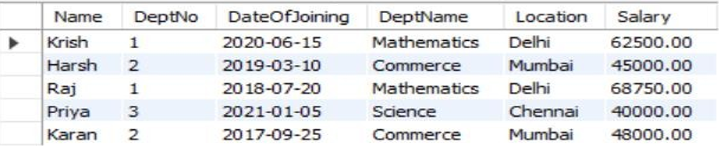
( c ) Perform Rollback command
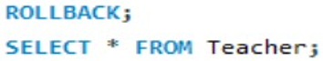
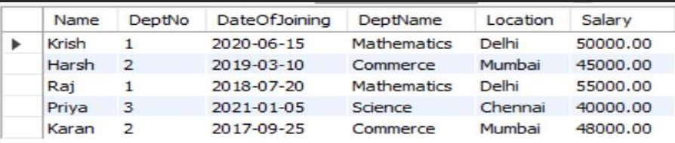
(d)GiveIncrementof15%salaryforCommerce Department
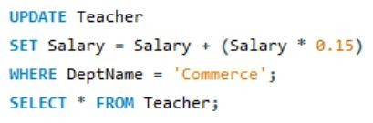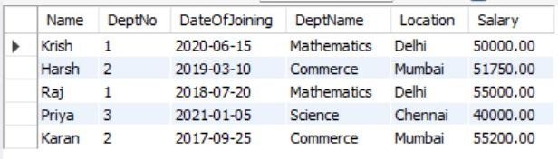

( e ) Perform commit command

ASSIGNMENT : 8
(Exercise on order by and group by clauses) Create Sales table with the following fields ( Sales No, Salesname, Branch, Salesamount, DOB)
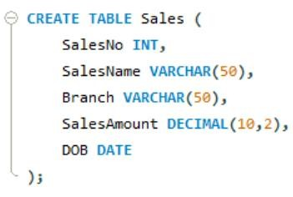
( a ) Insert five records

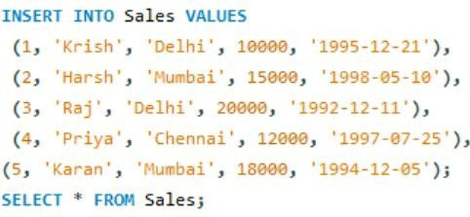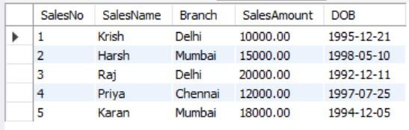

( b ) Calculate total salesamount in each branch

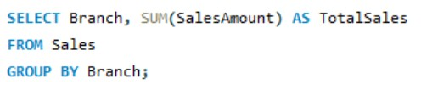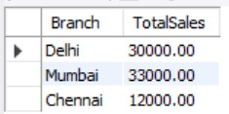

( c ) Calculate average salesamount in each branch
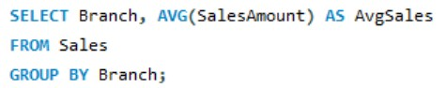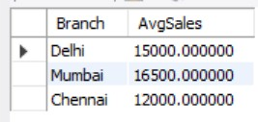

( d ) Display all the salesmen, DOB who are born in the month of December as day in character format i.e. 21-Dec-09
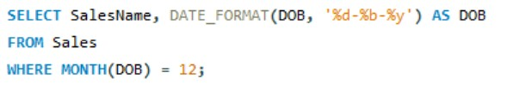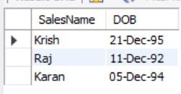

( e ) Display the name and DOB of salesman in alphabetical order of the month.

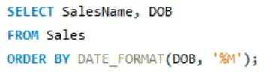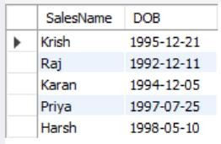

ASSIGNMENT : 9
Consider the following tables namely “DEPARTMENTS” and “EMPLOYEES” Their schemas are as follows,
Departments ( dept no , dept name , dept_location ); Employees ( emp_id , emp_name , emp_salary,dept_no);
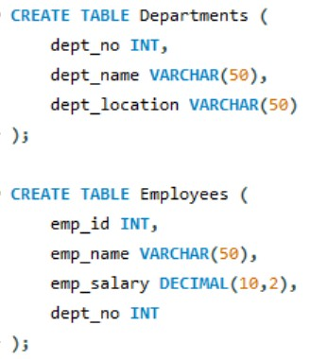
a)Develop a query to grant all privileges of employees table into departments table
b)Develop a query to grant some privileges of employees table into departments table
c)Develop a query to revoke all privileges of employees table from departments table
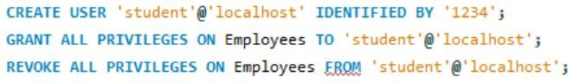
d)Develop a query to revoke some privileges of employees table from departments table
e)Write a query to implement the save point.
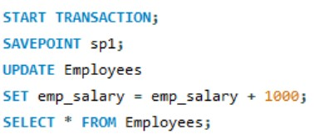
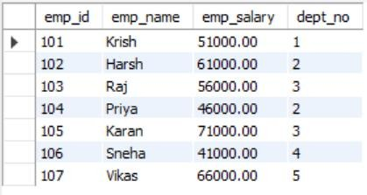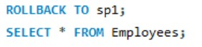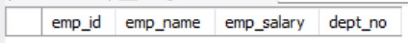

ASSIGNMENT : 10
Using the tables “DEPARTMENTS” and “EMPLOYEES” perform the following queries
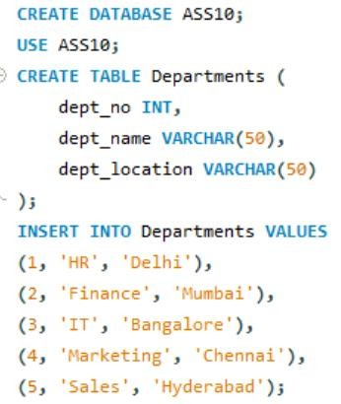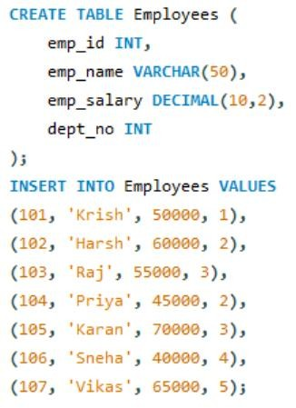

a)Display the employee details, departments that the departments are same in both the emp and dept.
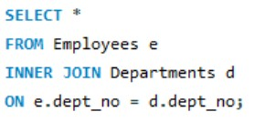
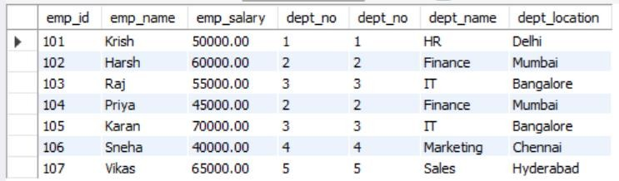
b)Display the employee name and Department name by implementing a left outer join.
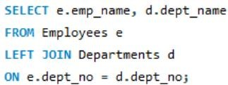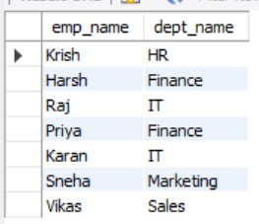

c)Display the employee name and Department name by implementing a right outer join.
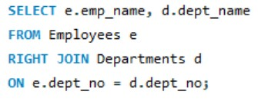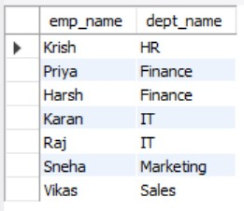

d)Display the details of those who draw the salary greater than the average salary
